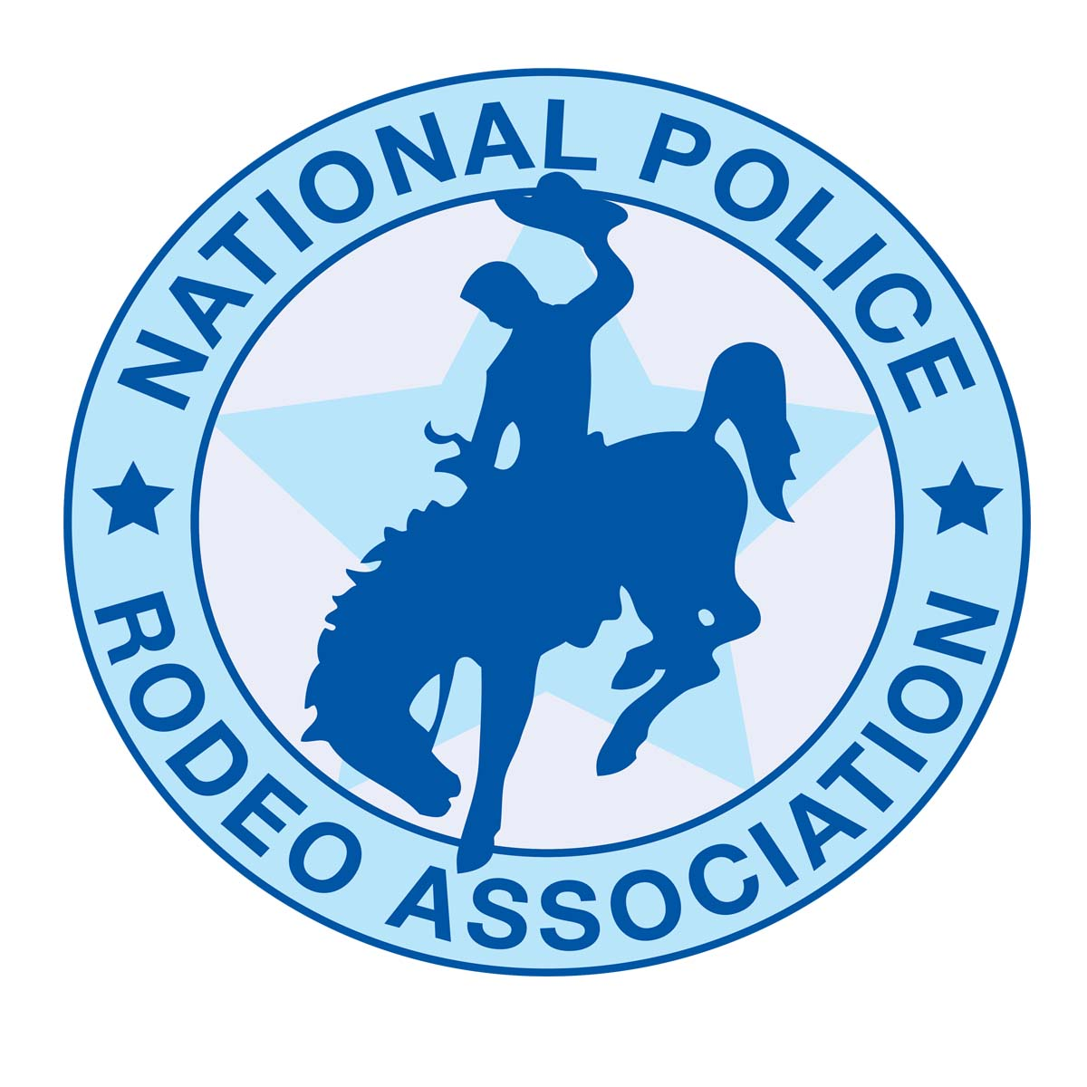
P.O. Box 2351
Yucca Valley Ca, 92286
kwbmmn@msn.com
(760) 218-1980

Non Profit Tax ID # 33-0210906

Subject: 2017 Request for sponsorship
From: National Police Rodeo Association

Mission Statement: Our mission as a nonprofit organization is to bring together member’s to compete in various rodeos around Southern California promoting wholesome values in the spirit of friendly competition.
Proceeds from our rodeos are donated to charities that benefit disabled children such as North American Handicapped Riding Association and Special Olympics. Traditional rodeo events are featured in performances, along with events not seen in Professional Rodeo Cowboys Association. In addition to the usual Saddle Bronc, Bull Riding, Calf Roping, Team Roping, and Barrel Racing, we showcase a number of non-traditional events which allow family members of all ages to join in the fun.
While the crowd may laugh at the antics of Calf Dressing, the competitors are extremely serious, and they are in it to win it!

- Donation request: monetary sponsorship
- Where: Rodeos all over Southern California mainly Riverside and San Bernardino Counties
- When: Minimum of five rodeos
- Targeted Audience: 100+ competitors, 200-1000 Spectators
- Advertising opportunities.

NPRA will

1. Display your banner/s
2. Frequent public announcements
3. Company name and Logo on bucking chutes, for larger sponsor levels, this allows name and Logo in all contestant photos used for advertisement.
4. Company name and Logo on our website for the entire year.
6. Company name and Logo on barrels larger sponsor levels.

2017 Sponsorship Opportunities

Silver - $250.00 this donation gives you:

- Your business card on our website

- 1- Banner in arena for the Rodeo (provided by sponsor) Public announcements during opening ceremonies for the entire year

Bronze -$500.00 this donation gives you:

- Company name and logo on one part of our year end saddles
- 1-Banner in the arena for the entire year (provided by sponsor)
- Public announcements made during opening ceremonies for the entire year.
- Company name and logo on any promotional flyers and our website for the entire year.

Gold -$1000.00 this donation gives you:

- Company name and logo solely on a saddle of one of our year end winners.
- 1- Banner with in the arena for the entire year (provided by sponsor)
- Public Announcements made throughout duration of the event and introduced during opening ceremonies for the entire year.
- Company name and logo on promotional flyers and our website for the entire year.

Platinum Sponsor- $5000.00 - (Annual sponsor) or $2,500.00 (Individual Rodeo) this donation gives you:

- 2 Banners in the arena for the entire year.
- All four saddles with your company name and logo on them solely.
- 1 banner in high traffic show grounds for the entire year ( We request that each sponsor provide their own banners)
- Pictures of our all around saddle winners beside your banner, with sponsored saddle.
- Public announcements made throughout duration of the rodeo and introduced as our Platinum Sponsor during opening ceremonies for the entire year.
- Company name and logo on promotional flyers, NPRA Face Book page and our website for the entire year.
- Your company name and logo on any and all awards we give during the year at Rodeos.

Additional Sponsor Opportunities

- Sponsor barrels- your company name and or logo on complete barrel cover, to include all three barrels in the arena during Barrel Racing event for the entire year of 2017 (examples will be attached to this letter)…. $3000.00

- Buy a 1/3 section of the Barrel- your company name and or logo on a 1/3 section of the barrels in arena during Barrel Racing for the entire year of 2017 (examples will be attached to this letter) $1,500.00
- Arena banners (provided by sponsor) $250.00 (examples will be attached to this letter)
- Flag Sponsor- $300.00 per Rodeo

On behalf of the National Police Rodeo Association, We would like to thank you for your time and any sponsorship/ donation you may be able to provide.

We look forward to another awesome year!

Sincerely, Missy Buchanan (NPRA Secretary) Email: kwbmmn@msn.com
Website: gonationalpolicerodeo.org

National Police Rodeo Association
2017

Name:________________________________________________________

Name of Business:_____________________________________________________

Address:______________________________________________________

_____________________________________________________________

Telephone#:___________________________________________________

Contact person:________________________________________________

Your sponsor:$_____________________________________________________

Your website Address http://________________________________________________________

A note regarding your business for our announcer:

_____________________________________________________________

_____________________________________________________________

_____________________________________________________________

_____________________________________________________________

_____________________________________________________________

Vender Space Requested @ no charge: Yes or No

Please be sure to email your company logo to kwbmmn@msn.com

Please mail your donation to:
National Police Rodeo Association
P.O. Box 2351
Yucca Valley Ca, 92286

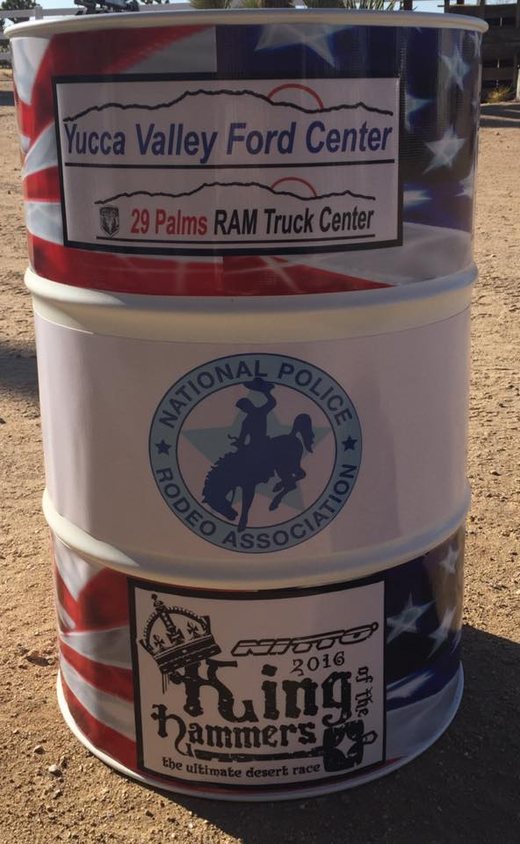

Examples of barrel advertising.
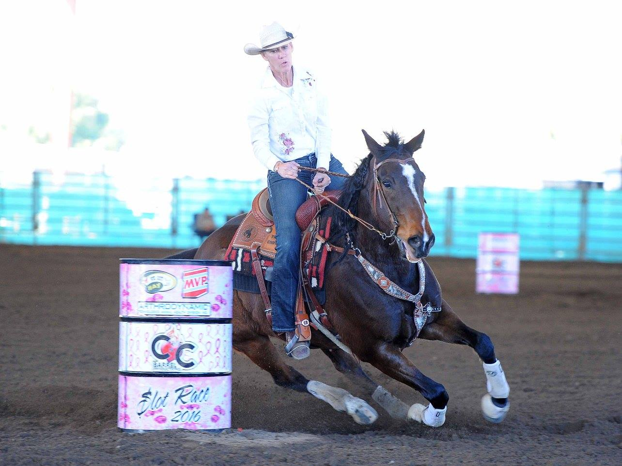

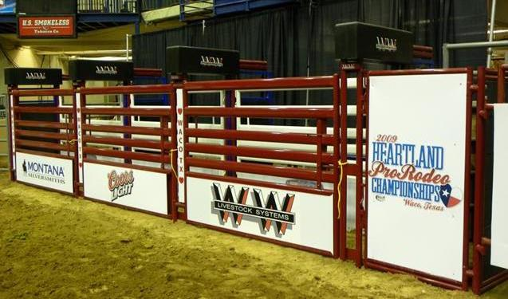
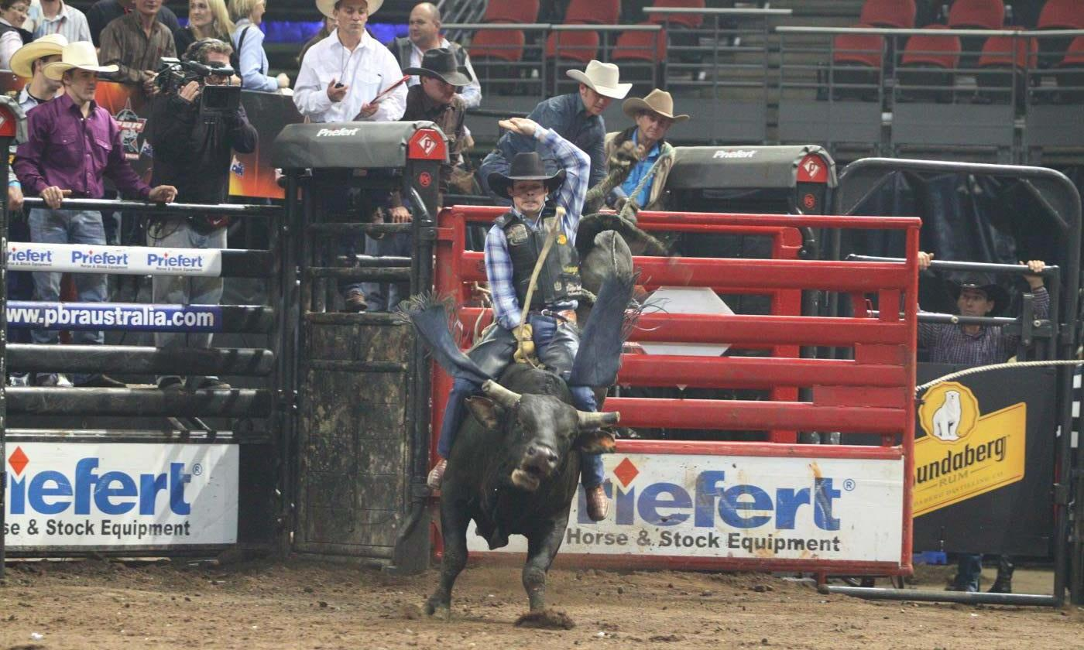
Examples of bucking chutes and arena advertising.

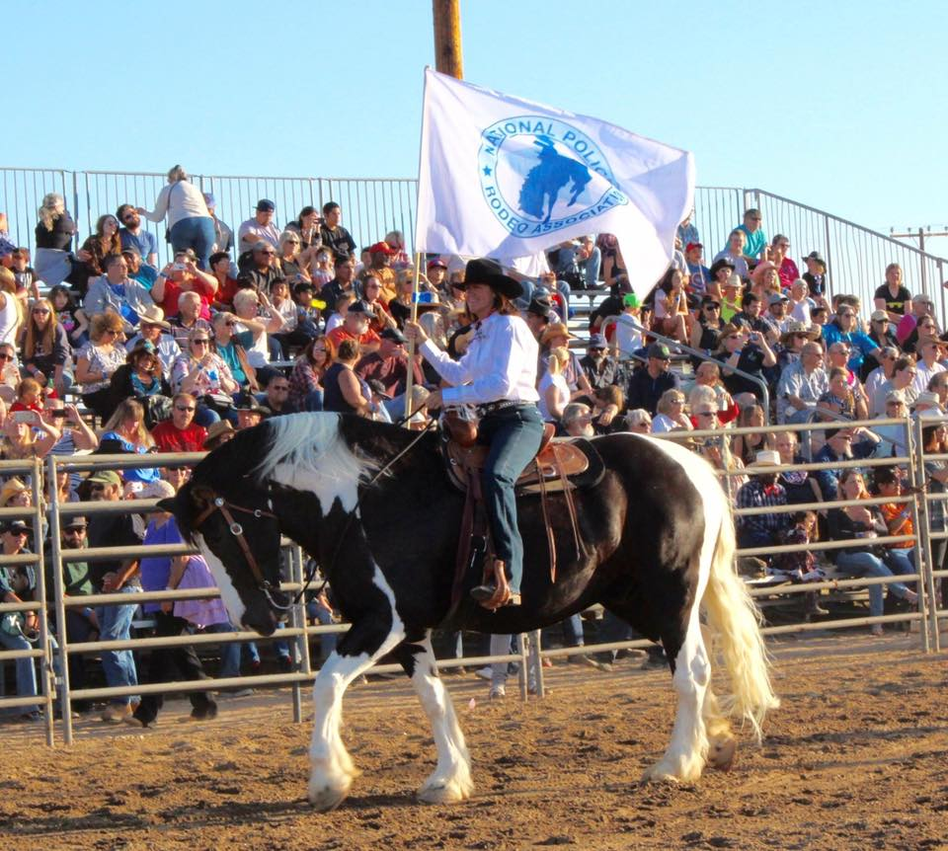
Examples of arena flag’s during Rodeo

